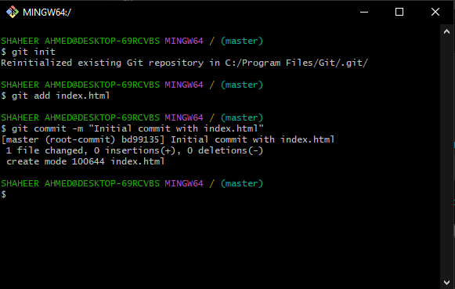**Bytewise Fellowship program (Data Science)**

TASK 1:

An introduction to Git